Task Instructions

You will be participating in a gambling task that could result in a Cash reward $$$ based on your performance. In each gamble you will have the option between a set amount or a gamble. If you select the set amount, you will receive that amount of money. You will then be shone what you would have received if you took the gamble. If you select the gamble, you will have a 50/50 chance at earning more money than the safe bet or less money than the safe bet. The safe bet can be negative, positive, zero. You will make your selection by using the left or right arrow keys. A total Score will be presented in the top left corner of the screen. You will receive the total amount at the end of the experiment.

GAMBLE

Example Gambles

Positive Gamble Negative Gamble

50/50 Chance Safe Bet 50/50 Chance Safe Bet

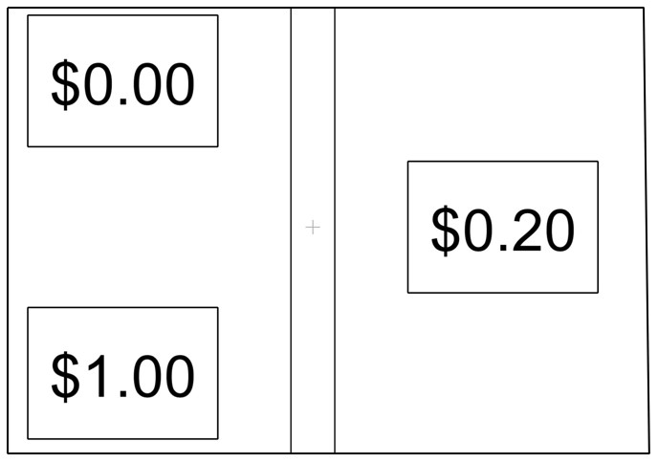 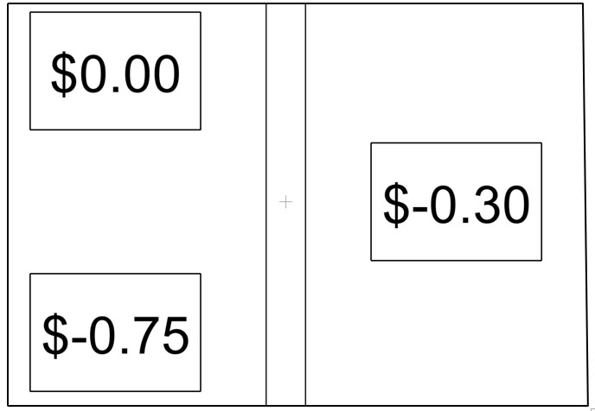

If you select the gamble, there will be a brief delay followed by the outcome. The outcome will be colored green for good outcomes or red for bad outcomes.

If you select the safe bet, you will be presented with how much you won or lost in either green or red respectively. Then after a brief delay you will see the outcome, of the gamble. If choosing the safe bet was a favorable choice, it will be presented in green. If choosing the safe bet was an unfavorable choice, it will be presented in red.

Happiness Scale

At the beginning of the task as well as throughout the experiment you will be asked to give a self-report of your current happiness level. The scale will be from 0-10 ranging from very unhappy to very happy. To move your cursor, you will use the left and right arrow keys. You can confirm your selection by pressing either the down arrow or the spacebar. Please use an accurate representation of any change in your happiness and use as many numbers as you deem necessary.

Example Happiness Rating

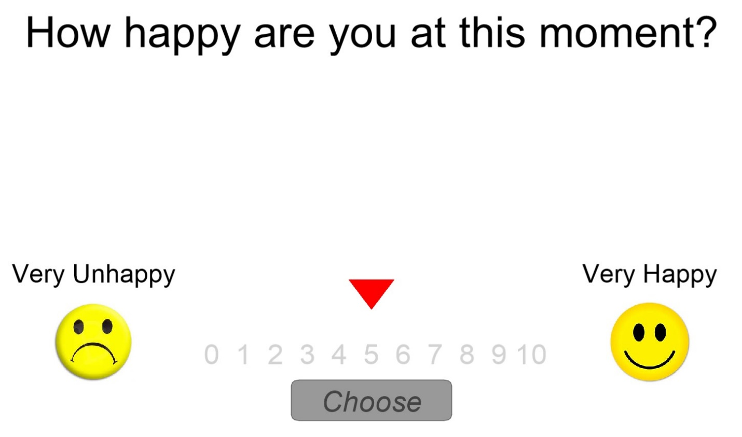

You will have practice trials to get a feel for the timing. If you have any questions or which to start signal the researcher. Good Luck!